*Who's Refuge?*

## Team Graph Giraffes

### Designed by Adam Gazdecki, Cole Lewis, and Kora Loudermilk

# Overview

*Who's Refuge?* is an exploration-adventure game in which the player navigates an environment and solves puzzles around the world in order to progress. This game draws inspiration from games such as The Legend of Zelda and Myst. The core mechanics include utilizing visual hints from differing environments; exploring the island in the pursuit of answers to mysteries; solving puzzles to access new areas and items; and seeking and thinking about helpful items.

*Who's Refuge?* may include enemy entities and weapons as a means of fighting them, however, per the ESRB, we will ensure that any fantasy violence present will be moderate and unrealistic enough to adhere to an E for Everyone rating by eschewing all blood effects or macabre depictions of death.

The Legend of Zelda, referring to the series at large, is a mainstay of both action-adventure and action-role-playing (ARPG) games. The first iteration of the series is arguably the progenitor of the modern genre. Succeeding iterations have built upon the original concept of dungeon-exploration, fighting enemies, and collecting items. However, with the switch to 3D with Ocarina of Time, players first encountered a rich, dynamic environment with dungeons, or “temples” and their accompanying puzzles over three axes. The inclusion of verticality required spatial reasoning and critical thinking on behalf of the player, a good example of this being the game’s Water Temple, which requires you to lower and raise the water level in order to access and trigger switches.

Myst, also referring to the series at large, is a graphic adventure and puzzle game in which players travel across predetermined points within a world and solve puzzles and uncover mysteries in their environments in order to further the narrative. As the series has evolved, graphical fidelity and strength of the narrative has grown.

We hope to incorporate elements of each listed game series into *Who's Refuge?* by including core aspects such as:

1. The necessity of solving a logical puzzle in order to further the narrative.
2. The ability to explore and traverse the world freely.
3. The necessity of constant awareness in your environment to deduce hints and other information from surrounding artwork, items, etc.
4. The development of the world, and story of what happened, to encourage the player to want to progress more.

The first fifteen minutes of the game would be spent getting accustomed to movement controls and learning about the environment. You’ll leave the start area guided by writing on the wall until you make it outside.

The player’s ultimate goal is to escape the island. This is done by solving a series of puzzle chains at three locations in order to earn keys to the final door. Through this mysterious door that the narrative builds around is the final escape from the island.

### Concept

Our team will mainly use music and associated audio effects in order to create a sense of isolation and anticipation, as if something is around the corner at each moment. Through the setting, various songs will play depending on the surroundings, ranging from light-hearted and upbeat to foreboding and mysterious. We will also build tone and give the player feedback through the use of special effects like particles emitting upon solving a puzzle, picking up an item, colliding with enemies, or use of specific items.

Visually, *Who's Refuge?* will employ a low-poly style. Below is an example of a key item, the blue key.

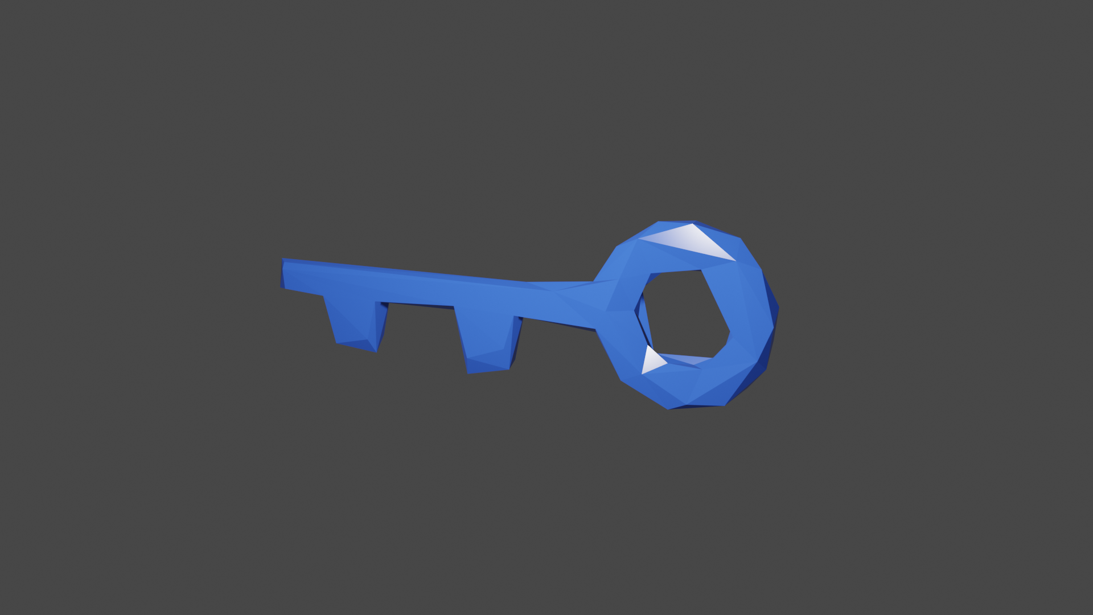

Attached below, as well, is a conceptual map of the island and where each key will be located. Do note, this map does not represent a final product and any to all attributes are subject to change. After completing each puzzle chain, we plan to fill out and detail the world more.

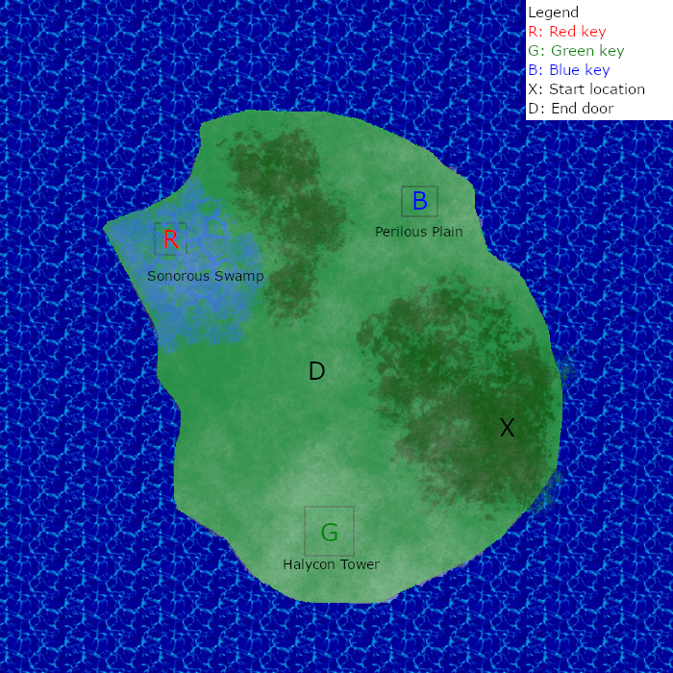

Here the map displays terrain and planned locations of where each key, and puzzle cluster, is located, and where the player starts. Unlisted on the map will be extraneous landmarks, easter eggs, secret items, smaller puzzles that may give the player an advantage, and other miscellaneous features that are not paramount to story progression.

### Gameplay

The player will need to complete three separate puzzle chains in different areas. Each chain gives the player access to a key, in order to finish the game. Each area will feature a separate and unique environment that requires the player to observe their surroundings for information and clues, utilize different movement mechanics, recognize new patterns that arise from each area, and experiment with interactable objects. The completion and gain of each key can be done in any order, although some key quest areas may require the player to have found an item located elsewhere on the island. We want the player to have non-linear access to the puzzle chains so that they are open to picking and choosing their challenges. The world’s non-linearity encourages the player to take their own unique approach to traversing the world and optimization over multiple playthroughs.

In the course of each puzzle, the player will be asked to manipulate the environment in the course of some puzzles by means of switches, matching items, or pressing buttons in a certain sequence. Puzzles may also include enemy interactions in which you’re required to defeat them in a special sequence or otherwise.

The gameplay loop will consist of

1. Player explores the map.
2. A puzzle is found by the player from visual clues and the environment.
3. They formulate a solution and attempt it. They succeed, retry the puzzle, or decide to go back to step 1.
4. Player is presented with a reward and returns back to step 1.

On the map will also be hidden collectables that will reward the player for exploration. This will encourage the player to take their time within step 1 of the gameplay loop. The collectables will not offer a tangible reward to the player other than the satisfaction of their collection and the drive to 100% the game.

Alongside collectable items present in the world are pieces of equipment that some puzzles may rely upon, remaining unsolvable unless the corresponding item is equipped. Equipment can be purchased using coins collected by the player throughout the world.